CHRONIC PAIN IN CORNWALL
Information for patients
“My doctor wants to reduce and stop my painkillers – why?”

Many patients living with chronic pain find the idea of reducing and stopping painkillers surprising and illogical. Some feel scared or angry. This leaflet will explain the reasons why your doctor believes that this approach is in your best interests. We are referring to opioid painkillers in patients with chronic non-cancer pain.

What is an opioid?
An opioid drug is one that works in the same way as the drug morphine. They are sometimes called opiates. Opioid drugs include morphine, diamorphine (heroin), oxycodone, fentanyl, codeine, tramadol and buprenorphine.

Why might reducing my opioid be helpful?

- They are very likely to not be helping your pain. The scientific evidence states that sometimes they help pain for a month or two and then the benefit wears off. Many patients drop out of trials because of side effects. There are no decent clinical trials lasting over 3 months showing reduction of pain levels or better quality of life scores versus placebo.

- When patients in pain on opioids are compared with patients in pain who are not on opioids, those on the drugs tend to have more pain, a worse quality of life, more side effects and are less likely to be in employment.

- EVERYBODY who takes these drugs for long enough get tolerant to them. This means that increasing doses are required for the same effect. If you think that your opioid is helping because you feel rotten and have increased pain if you miss a dose - it may be that these are in fact withdrawal symptoms. Patients find that after a slow reduction and eventually stopping the opioids - their pain is often no worse and sometimes it’s improved. Lowering the dose is very likely to make you feel better in yourself too - once you've got through your withdrawal symptoms.

- Reducing opioids may reduce pain. Yes, you read that correctly! We are not clear why this happens, but the condition of “Opioid Induced Hyperalgesia” may often be involved. This is the phenomenon whereby increasing the dose of opioid surprisingly increases pain. It is more common when opioids are taken at high doses, and may be the reason many patients end up on high doses but still experiencing severe pain. These drugs increase the sensitivity of the pain nerves – a bit like turning up the volume on loudspeakers.

- Opioids affect the bowels. Bowel relaxes, leading them to become distended (stretched). This leads to constipation and abdominal pain. In patients treated for abdominal pain with opioids, this may lead to the Narcotic Bowel Syndrome. After an increase in the dose of opioid, pain is relieved for a few days, then slowly returns to its previous level, or worse.

- Opioids affect hormones. This is part of the reason that patients taking opioids tend to be miserable. Opioids particularly reduce sex hormones, which may lead to reduced sexual drive or performance.

- Opioids increase the risk of death, particularly at high doses.

- Your driving might be impaired. There are strict rules for driving when using opioids, which you need to be aware of.

Cornish GPs and specialists have teamed up to write local information to help patients suffering from chronic pain in Cornwall – please see the attached flyer to read and listen to their work.

We understand that the idea of reducing your painkillers might make you feel very nervous however recently medical research is showing us without a doubt that these drugs are harmful and very rarely help.

Your GP will guide you in a reduction program at a slow pace – it might take 6 to 12 months – which means that your body won’t notice the dose reductions too much and it shouldn’t be too uncomfortable. Please trust us that you are likely to feel better once it’s done AND you won’t be running the risk of side effects.

Dr Keith Mitchell
Consultant in Pain Medicine
Royal Cornwall Hospital
July 2017

CHRONIC PAIN
Information for patients in Cornwall

Pain usually alerts us to an injury, like a fire alarm alerting us to a fire.

That’s fine – it tells our body to pay attention to the injury and make us rest and get better.

But sometimes the pain goes on after the injury has healed. Or pain comes out of the blue for no apparent reason. If it goes on for more than 3 months we call it chronic (or persistent / long term) pain. Think of it as a faulty fire alarm – alerting us to danger... except there’s no fire.

Cornwall GPs, pain specialists and, importantly, patients have teamed up to write information which includes video, audio and onward links to other resources to help you manage chronic pain yourselves (with less emphasis on medications) and reduce the impact it has on your lives.

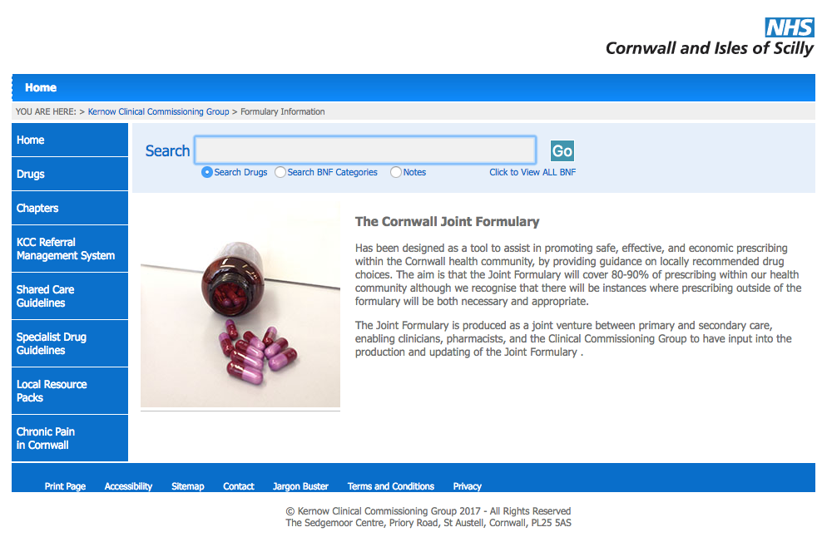
We hope you find it helpful

To find it.... go to

www.eclipsesolutions.org/cornwall

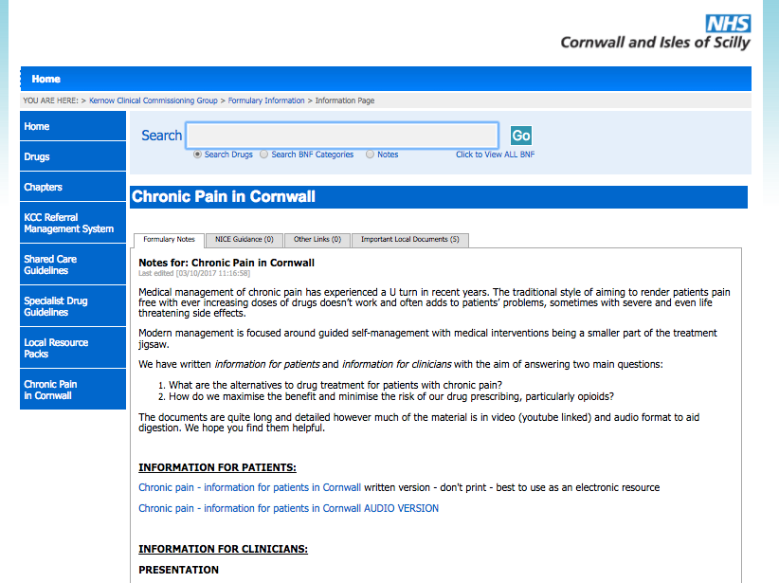
Then follow the link at the bottom
left of the page -
“Chronic pain in Cornwall”

Find the “information for patients” section

